**Monitoring with CloudWatch**

Steps:

1.Login to amazon console and go to SNS dashboard Click on create new topic and then type topic name and display name 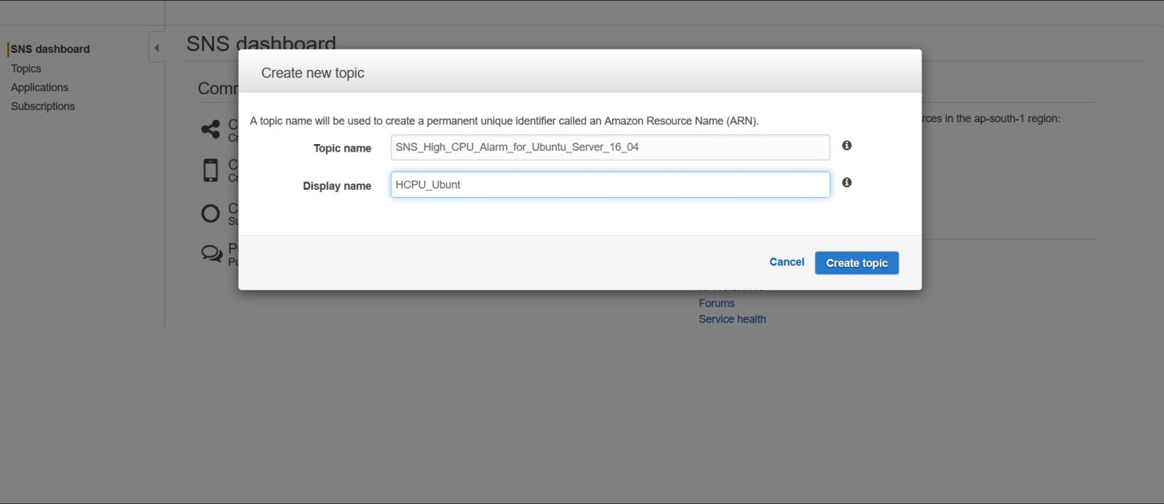

2.Click on Request Confirmations 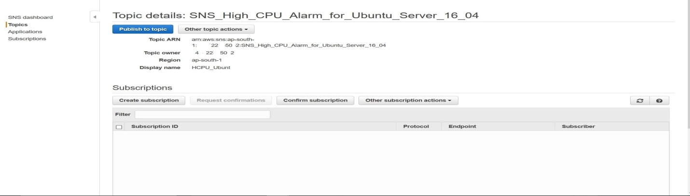

3. 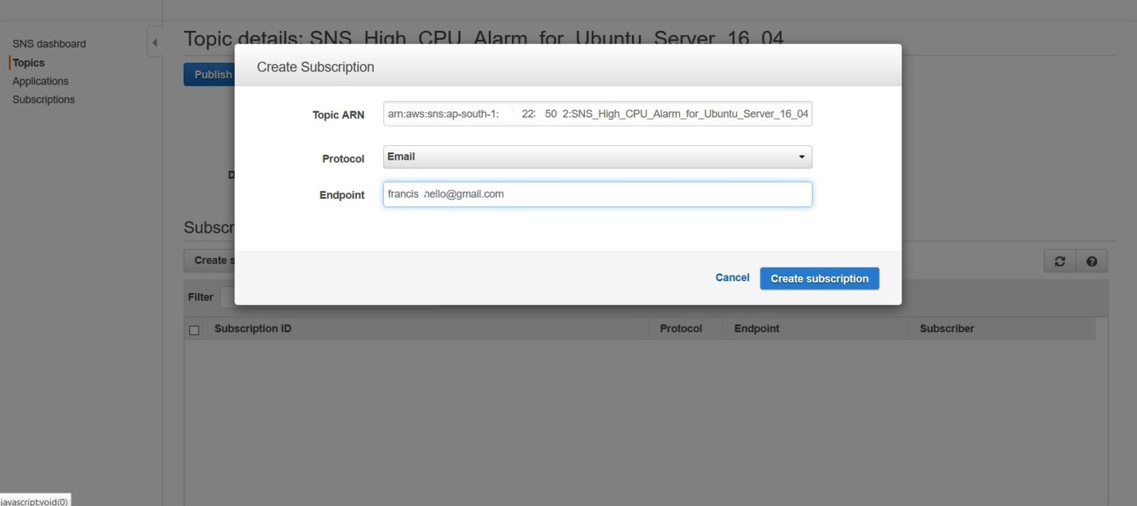

Create the subscription by selecting the precreated topic .Select the protocol as email and give the email id as the endpoint and click on create subscription

4. 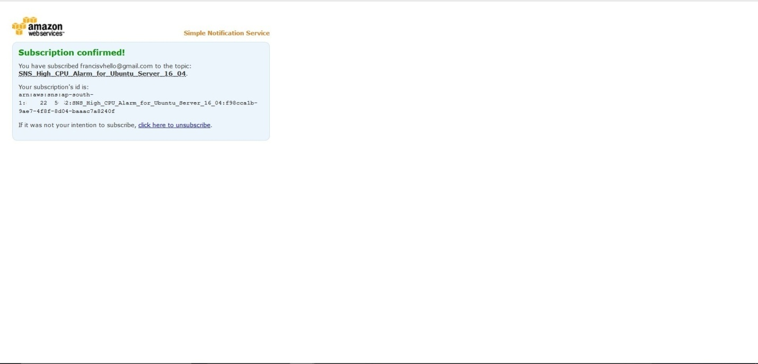

5.Create a Ubuntu t2micro instance at ap- south-1a 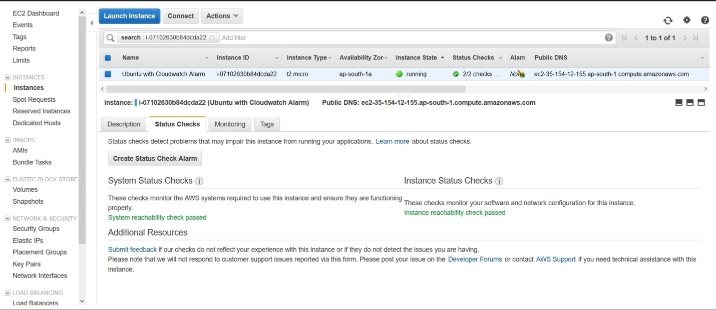

6.Click on create status check alarm and create an alarm as below

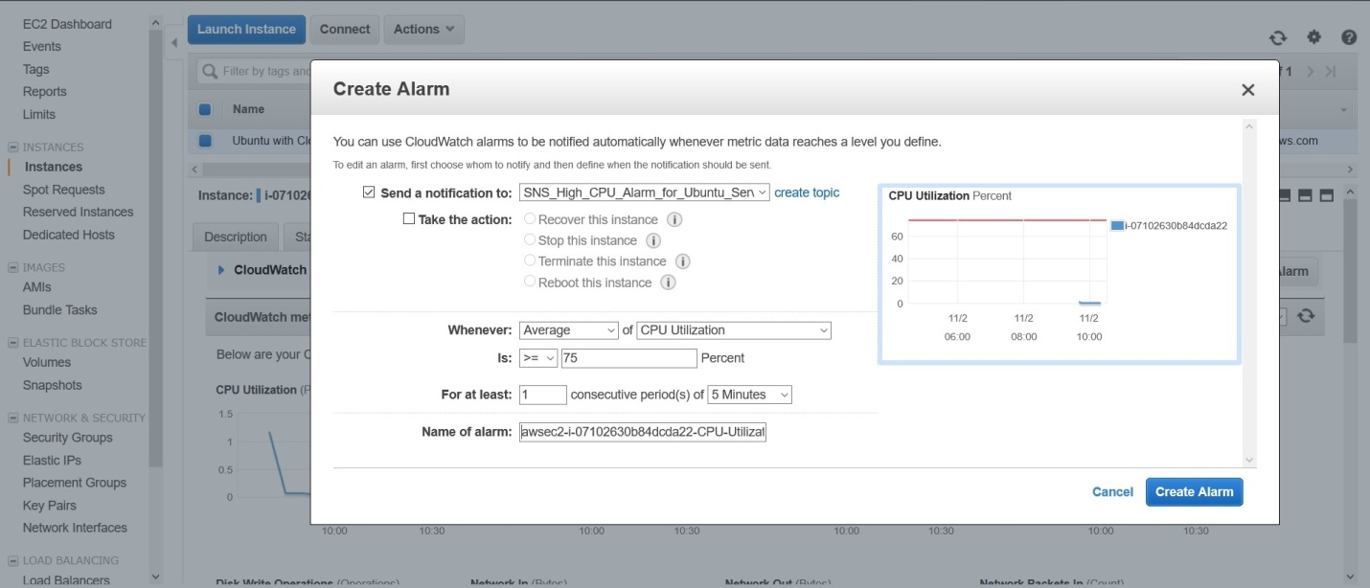

7.Goto cloudwatch >Alarms

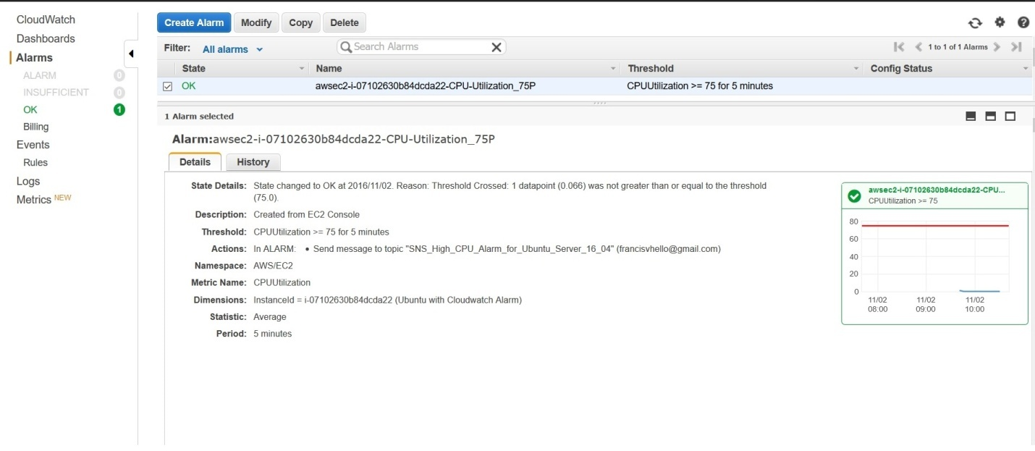

8. 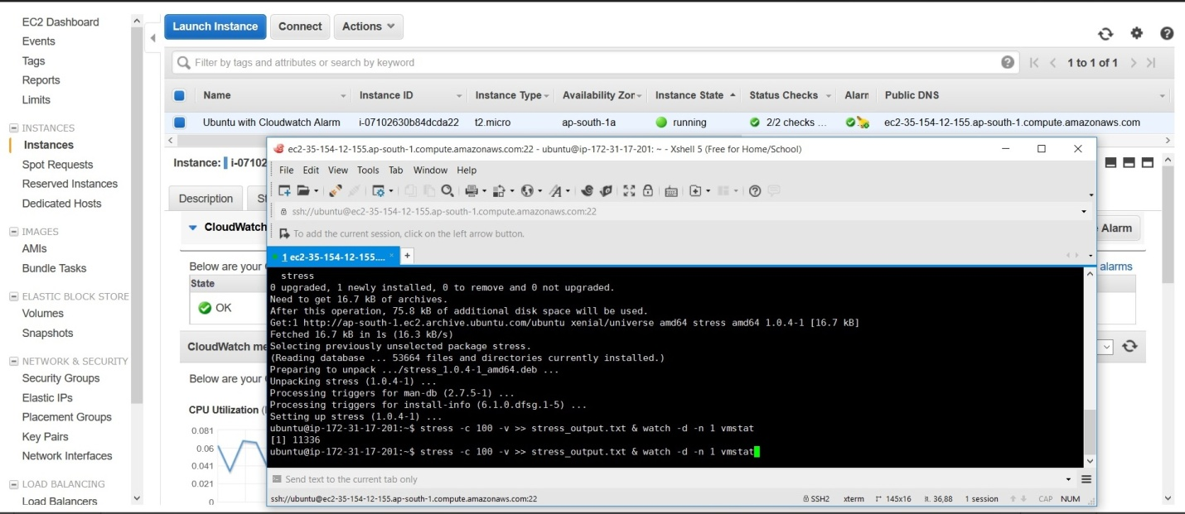

Connect to the ubuntu server then upgrade linux

Type apt-get install stress

Then type stress –c 100 to add 100 CPU stress

Type top to monitor the CPU performance

9. 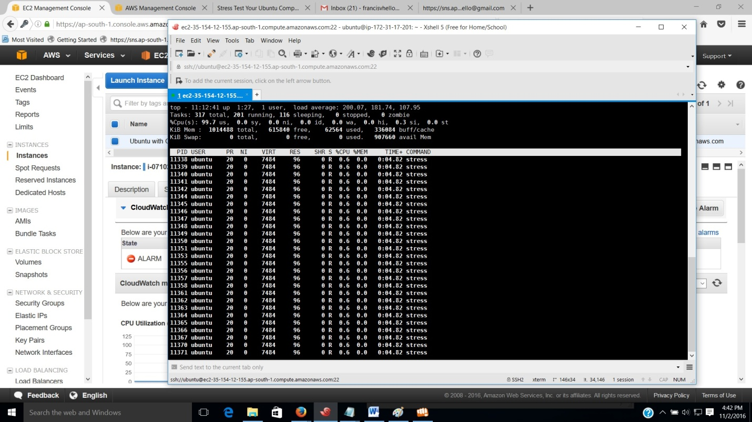

10.The alarm can be viewed in the in the inbox of the gmail

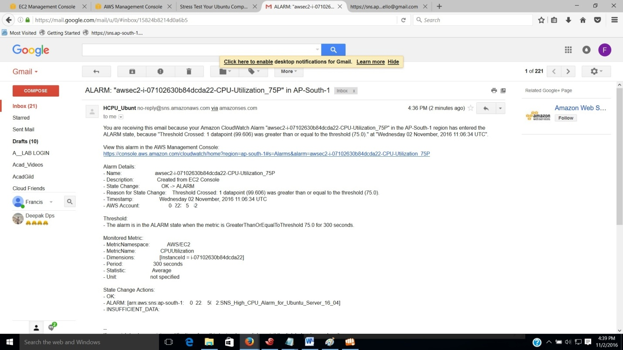

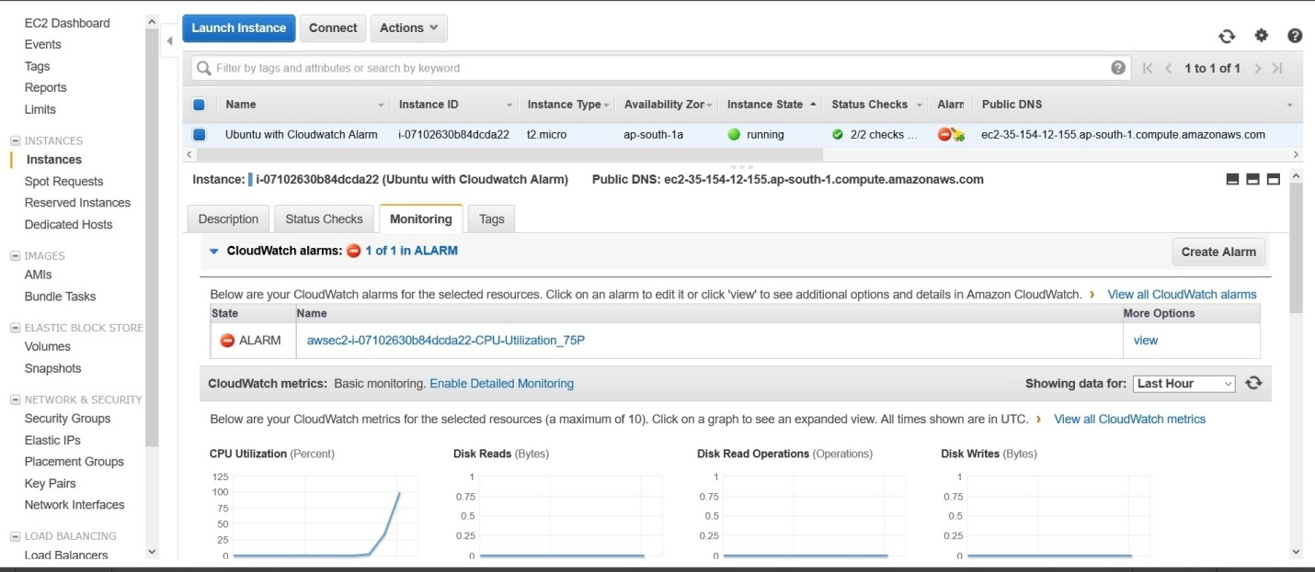

11.The CPU utilization can also be viewed by clicking in the monitoring tab ,also a corresponding rise to 100 can also be seen in the CPU Utilization percent graph.

iugiejjthk

3thi0j[f